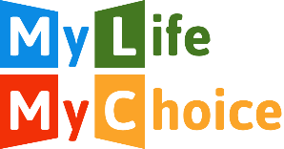
Membership form

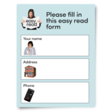 | Please complete this form if you would like to be a member of My Life My Choice.
 | As a member you will be able to get involved in MLMC projects and activities.
 | Membership is free.
 | We will not give your information to anyone else.
 | For our Privacy Policy, please visit our website or call us on 01865 204214 and we will send you a copy in the post.

My Personal Information
My name is…

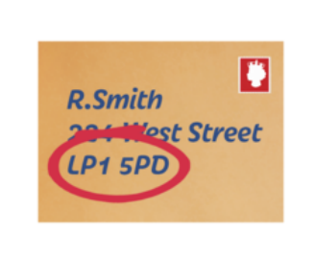 | My address is…
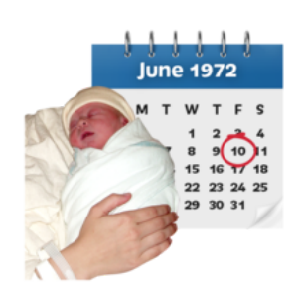 | My date of birth is (Day/Monday/Year)…
 | My telephone number is…
 | My email address is…
Newsletters
Would you like us to send you our monthly newsletter by post?

Please tick the box that suits what you want.

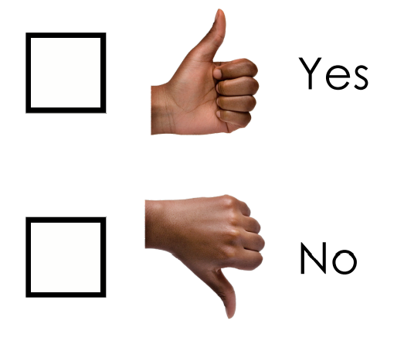
Would you like us to send you email updates about MLMC?

Please tick the box that suits what you want.
Please return this form to:
My Life My Choice
Unit 3, Watlington House
Watlington Road
Oxford
OX4 6NF
Or email it to:
sophie@mylifemychoice.org.uk

