Application to have a Gig Buddy

 | My Name is...
 | My Address is...
 | When were you born ? i.e 14/07/88
 | My telephone number is...
 | My email address is...
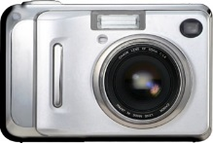 | Can we use your picture to promote Gig Buddies and My Life My Choice?
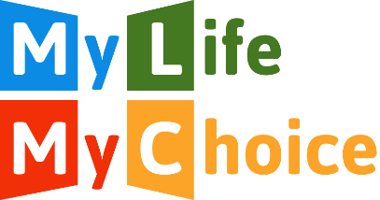 | Would you like to receive our newsletter and updates?
What activities or experiences do you enjoy?
This could include music you like, sports teams you support or places you are interested in going.

 | Do you have any preferences about the person you are matched with (age, gender, interests)?
 | Do you have support worker or PA and if so, how many hours a week do they work with you?
 | How do you get places? Do you travel alone or do you need support to travel?
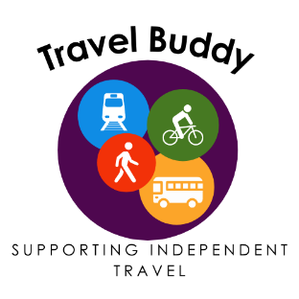 | Would you like to have a Travel Buddy who could help you travel to new places?
 | Do you have any specific health needs (e.g. epilepsy)?
 | Is there anything else that your buddy will need to know about support that you need?
Please could you give us the name of someone else we can contact if we cannot get hold of you:
Name:

Relationship to you:

Address:

Telephone:

Where did you hear about Gig Buddies? Please tick
MLMC Website

Facebook

Friend

Support worker
Other, give detail.........................
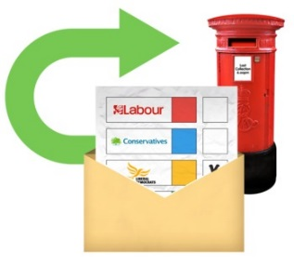 | Please send to:  Paula, My Life My Choice  Unit 3, Watlington House,  Watlington Rd,  Oxford, OX4 6NF  paula@mylifemychoice.org.uk  Your details will be saved on our secure drive and will not be shared with anyone else.

