
Membership form

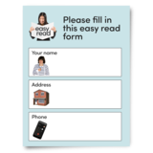 | Please complete this form if you would like to be a member of My Life My Choice.
 | As a member you will be able to get involved in MLMC projects and activities.
 | Membership is free.
 | We will not give your information to anyone else.
 | For our Privacy Policy, please visit our website or call us on 01865 204214 and we will send you a copy in the post.

 | My Personal Information  My name is…
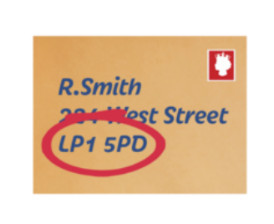 | My address is…
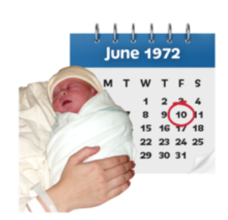 | My date of birth is (Day/Monday/Year)…
 | My telephone number is…
 | My email address is…
   | Newsletters  Would you like us to email you our monthly newsletter?  Please tick the box that suits what you want.  
 | Would you like us to send you email updates about MLMC?  Please tick the box that suits what you want.
If you don’t have an email address you can use a family members or supporters email address.

To request information in an alternative format, please call the office on 01865 204214.
 | Please return this form to:  My Life My Choice  Unit 3, Watlington House  Watlington Road  Oxford  OX4 6NF
Or email it to:
george@mylifemychoice.org.uk

