Application to have a Gig Buddy

 | My Name is...
 | My Address is...
 | When were you born? i.e 14/07/88
 | My telephone number is...
 | My email address is...
 | Can we use your picture to promote Gig Buddies and My Life My Choice?  
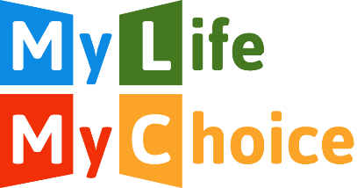 | Would you like to receive our newsletter and updates?
 | What activities or experiences do you enjoy?  This could include music you like, sports teams you support or places you are interested in going.
 | Do you have any preferences about the person you are matched with (age, gender, interests)?
 | Do you have a support worker or PA, and if so, how many hours a week do they work with you?
 | How do you get places? Do you travel alone, or do you need support to travel?
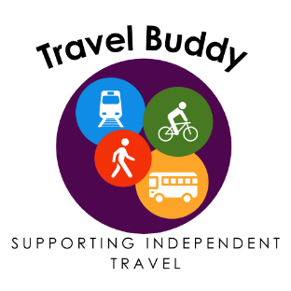 | Would you like to have a Travel Buddy who could help you travel to new places?
 | Do you have any specific health needs (e.g. epilepsy)?
 | Is there anything else that your buddy will need to know about support that you need?
 | Please could you give us the name of someone we can contact if we cannot get hold of you:  Name:  Relationship to you:  Address:  Telephone:
 | Where did you hear about Gig Buddies? E.g. Support Worker or our website.
 | Please send to:  Megan, My Life My Choice  Unit 3, Watlington House,  Watlington Rd,  Oxford, OX4 6NF  megan@mylifemychoice.org.uk  Your details will be saved on our secure drive and will not be shared with anyone else.

