Membership Form
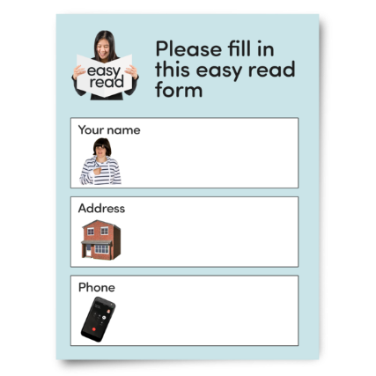
Please complete this form if you would like to be a member of My Life My Choice.
As a member, you will be able to get involved in MLMC projects and activities.


Membership is free.


We will not give your information to anyone else.


For our Privacy Policy, please visit our website or call us on 01865 204214, and we will send you a copy in the post.

 | My name is:
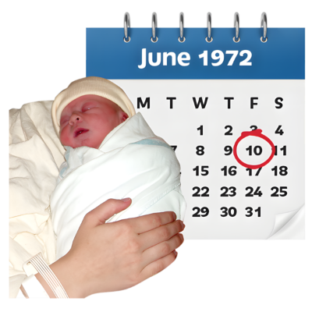 | My date of birth is:
 | My email is:
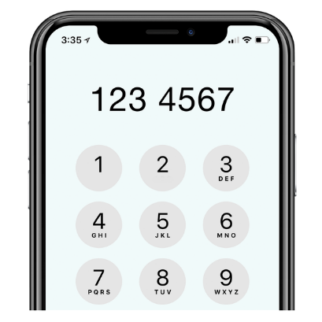 | My phone number is:
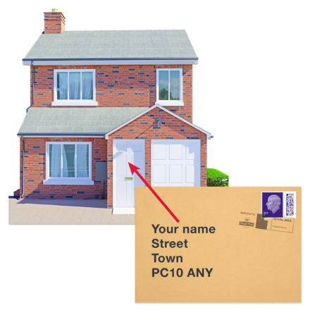 | My home address is:
 | Where did you find out about My Life My Choice?
   | Newsletters  Would you like us to email you our regular newsletter?  Please tick the box that suits what you want.  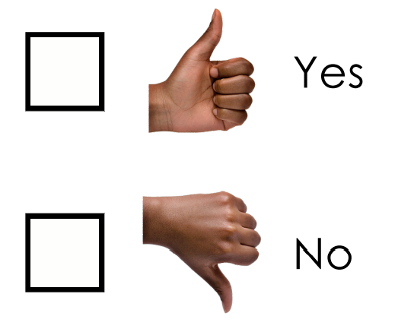
Newsletters
Would you like us to post you our regular newsletter?
Please tick the box that suits what you want.
   | Do you have a family member or support who would like to receive our email updates? Please share their email here:
   | Please return this form to:  My Life My Choice  Unit 3, Watlington House  Watlington Road  Oxford  OX4 6NF  Or email it to:  megan@mylifemychoice.org.uk

To request information in an alternative format, please call the office on 01865 204214.

